Ben Connor

Michael Terranova

Math 4350

1 May 2018

The Wilson-Cowan Model and its Application to Epilepsy

Introduction

Epilepsy is a class of neurological syndromes categorized by seizures, which are brief episodes of hyper-synchronized firing of neurons in localized areas of the brain such as the hypothalamus and cortex. The symptoms of a seizure can include involuntary movements of muscles and loss of consciousness (World Health Organization). The causes of epilepsy vary widely from genetics to diet, and for a minority of people, it is untreatable. Since epileptic seizures occur in regions of the brain where a neuron can have tens of thousands of synapses, micro-scale models (e.g. Hodgkin-Huxley, Morris-Lecar) can be very complicated for membrane potential analysis. On the other hand, the Wilson-Cowan model and its multiple extensions are very useful in demonstrating dynamical behavior in simple excitatory and inhibitory populations of nerve cells (Stefanescu et al. 752). Using bifurcation diagrams, time scales, and phase plane analysis of a simplified version of the model in the XPP and Neuron applications, we were able to replicate the waves of firing patterns found in the electroencephalograms (EEGs) of epileptic patients. We employed his method of comparison to show that the theoretical Wilson-Cowan model can reflect the clinical measurements (e.g. EEGs and MRI) taken on epileptic patients.

The Wilson-Cowan Model

Since many areas of the brain process large-scale spatiotemporally structured inputs that result in neural activity, computational neuroscientists need a macroscopic model to trace the average firing rate across several regions of the neuronal network. By using the idea from statistical thermodynamics that the random motion from particles is related to the mean ensemble motion of a whole fluid, Hugh R. Wilson and Jack D. Cowan (1972) derived effective equations for a large population of densely coupled neurons that are active per unit time (Kilpatrick 1). Wilson and Cowan assumed that the behavior of a neural network relies on the interaction of excitatory and inhibitory cells, which are respectively represented by the variables *ae(t)* and *ai(t).* Since *ae,i(t)* stand for proportions of nerve cells firing per unit time at an instant *t* in the population, both of the values lie between 0 and 1. Also, following from this, *ae, i(t)* = 0 correlates to a low-activity resting state, and excitatory (inhibitory) make the surrounding cells more (less) likely to fire, and the non-linear function *Fe* (*Fi*) of presently active cells gives the activation (Kirkpatrick 1). Typically, *Fe,i*  is a sigmoidal curve, but other distributions can be used. In this case the function is given by

  
where  is the gain and  is the activity threshold for the population, and the variable *x* is the weighted sum of *ae(t)* and *ai(t)*. From these assumptions, Wilson and Cowan yielded the following space-clamped system of first-order equations: 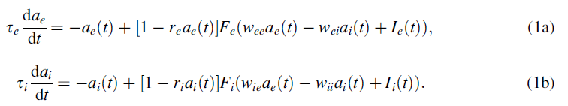

In the above equations, τj is the timescale that tracks the response of each subpopulation; *wjk*≥0is a parameter describing the strength of the connection from a cell type *j* to another type *k*;and the input function *Ij (t)* is a sum of currents arriving to a cell population *j* from an external source (e.g. another section of the brain or an electrode). In addition, the pre-factor [1 ─ *rjaj(t)*] defines the refractory dynamics of both subpopulations, which tracks the period of time in which cells can not be stimulated following an action potential (Kirkpatrick 2). With this model, various dynamical concepts can be demonstrated: Hopf bifurcations and subsequent limit cycles, hysteresis, and multiple stable fixed points.

Method

Having selected the Wilson-Cowan model as an ideal model for simulating the hyper-synchronous and excitatory behavior in epileptic because of its macroscopic qualities and direct representation of excitatory populations of cells, we had to find a suitable .ode file for modeling in XPP. Also, we looked for a .mod file for neuronal modeling in a similar application called Neuron because of its intuitive video recording of the behavior of phase planes and time series.

After visiting ModelDB, we found the following .ode file (known as wc.ode; the .mod file is named wc.mod) created by Bard Ermentrout:

# wilson-cowan

f(u)=1/(1+exp(-u))

par aee=10, aie=8, aei=12,aii=3,ze=.2,zi=4

par tau=1

i_e(t) = ie0+ie1*sin(w*t)

i_i(t) = ii0+ii1*sin(w*t)

par ie0=0, ie1=0, w=.25

par ii0=0, ii1=0

init u=.1, v=.05

u'=-u+f(aee*u-aie*v-ze+i_e(t))

v'=(-v+f(aei*u-aii*v-zi+i_i(t)))/tau

@ total=40

ra

done

This version of the Wilson-Cowan model was selected for its simplicity and similarity to the original model described in the previous section. In the ode file, u (analogous to *ae(t)* above) the variable which represents the proportion of active excitatory neurons and v (*ai(t)*) represents the active inhibitory population. The functions i_e(t) and i_i(t)are external inputs to the excitatory and inhibitory population, respectively. In order to account for the firing rate distribution, the rudimentary sigmoidal function f(u) is employed, where the argument u is not the same as the The parameters aie, aee, aei, and aii correspond to connectivity strength between the subpopulations (like *wjk* above). ie0, ie1, ii0, and ii1 are parameters controlling the input to each subpopulation (ie0, iel for the excitatory input; ii0, ii1 for inhibitory input); and w controls the frequency of the inputs. Instead of including the pre-factor [1 ─ *rjaj(t)*] for the refractory period, the parameters ze, and zi are used to control the delay. The timescale tau divides only the derivative of the inhibitory variable v’ because it can give us more control over the response of the inhibitory population. The wc.mod file for Neuron uses the same equations, variables, and default parameters.

With the wc.ode file, we started to run bifurcation diagrams in XPP for the variables u and v versus each parameter in the system, making sure that the other parameters were held in their constant state. This was done in order to find the Hopf bifurcations and subsequent periodic solutions of the system. Also, it gave us the opportunity to alter the values of the parameters to find multiple stable states and hysteresis, which is a phenomenon wherein if one parameter is altered even a little bit, the fixed point drastically changes location. The periodic solutions of the system are important in this case because they reflect the wave-like behavior of the average action potentials of neurons in one region of the brain, which is recorded on EEGs.

After this point, more alteration was done to the parameters and we gave the system some input in order to roughly simulate epileptiform behavior. Since the mechanism behind a seizure is synchronous and excitatory, we hypothesized that it was necessary to have solutions where the excitatory proportion dominated over the inhibitory proportion. Furthermore, it was ideal to find oscillatory solutions for the sake of accuracy to clinical data. By comparing our time series charts to the spikes from a particular EEG chart of a generalized tonic-clonic seizure, the behavior was successfully replicated. The tonic-clonic seizure was selected because it was one of the more common types of epileptic seizures, and because it is more apparent on EEGs because it affects the whole brain.

Results

By running the phase plane solution in Neuron with the default parameters and initial conditions *u*(*0*) = 0.1 and *v*(*0*) = 0.05, we found a stable spiral fixed point at (*u*, v\**) = (0.5311, 0.6233) below:

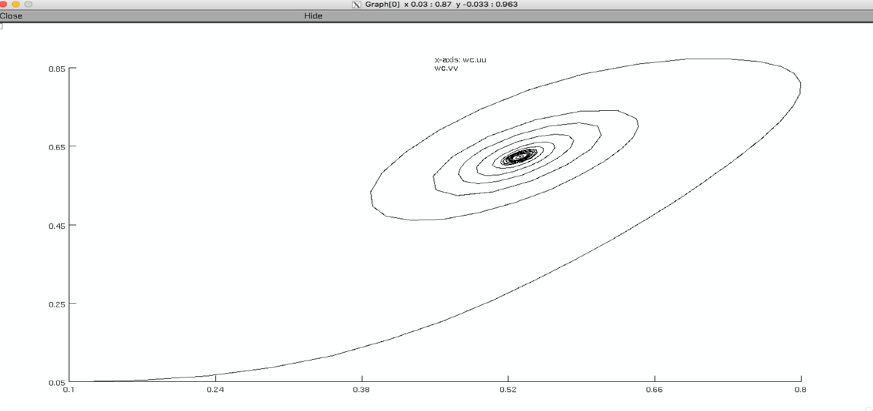

Next, in XPP we ran the following bifurcation diagram of the excitatory subpopulation (*u*) with respect to the excitatory-to-excitatory connectivity parameter (aee). The green dots represent a periodic solution of a supercritical Hopf bifurcation from aee* = 10.7871 to aee* = 11.3544:

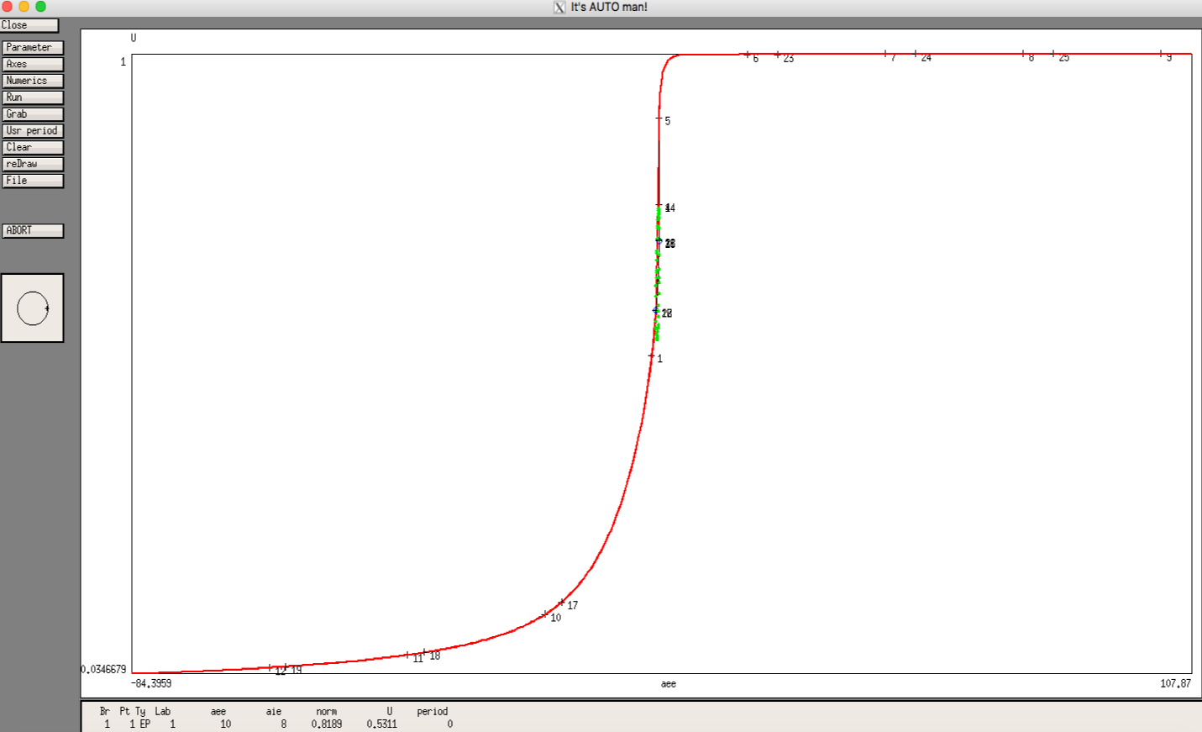

Here is a zoom-in of the periodic solution, hysteresis on red arm, and bifurcation:

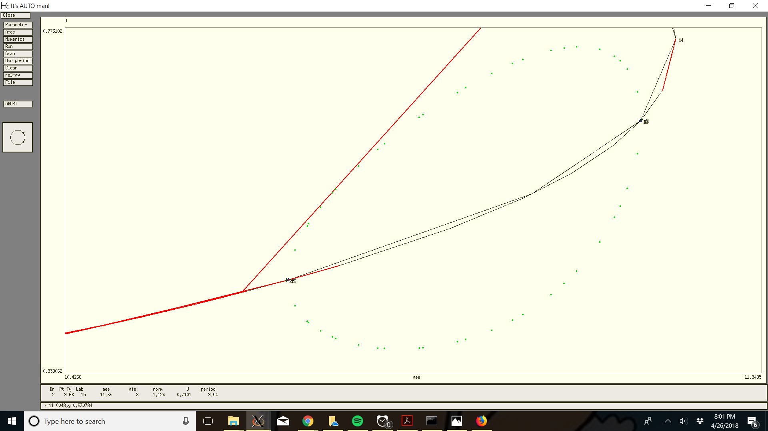

Returning to the (*u, v*)-phase plane, we changed aee from 10 to 11 to get the following periodic solution with an unstable spiral fixed point (rectangle in figure below) at (0.62986, 0.7746). The light blue lines are the stable trajectories; the black line is the stable limit cycle; the blue lines are the unstable trajectories; the green line is the *v-*nullcline; and the red line is the *u-*nullcline:

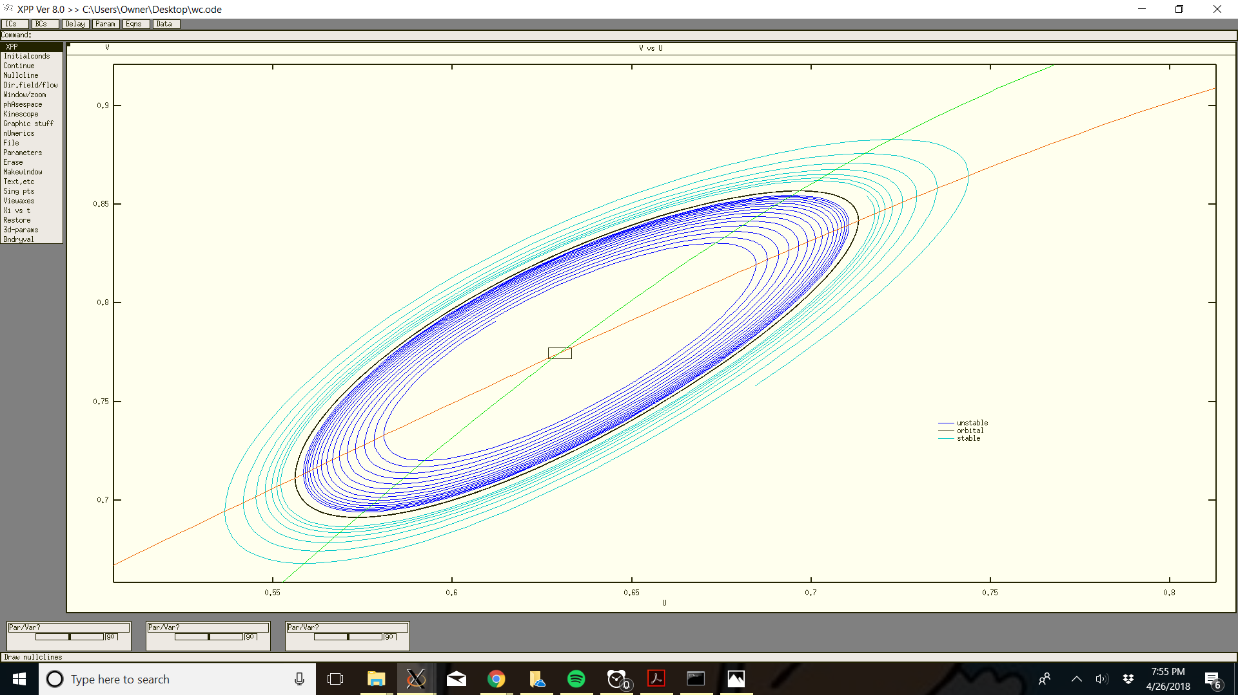

When aee=11.34, we still found a periodic solution from our default initial conditions repelling fixed point at (0.70402, 0.86463):

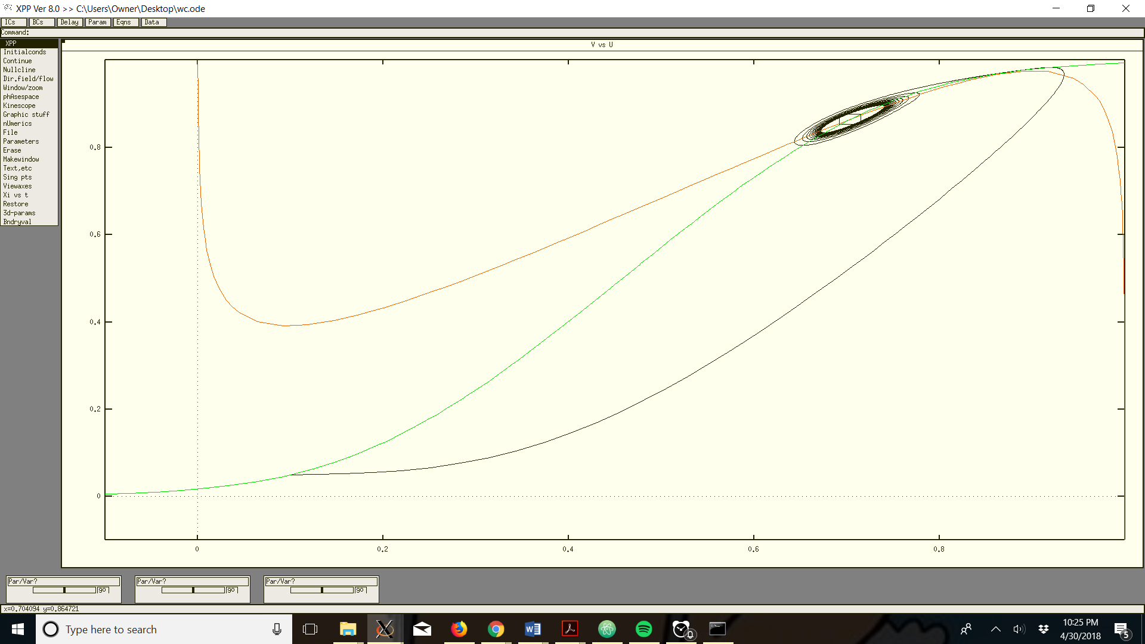

On the other hand, when we increased aee from 11.34 to 11.36, we found 3 fixed points: the left oval of the phase plane: a stable spiral; middle triangle: saddle node with invariant sets with a vomit-green line representing the unstable trajectory and the light blue line, the stable trajectory; the right oval is a stable node with strong sets drawn as blue lines). Since there are 2 stable fixed points, we have proven that the system displays bi-stability.

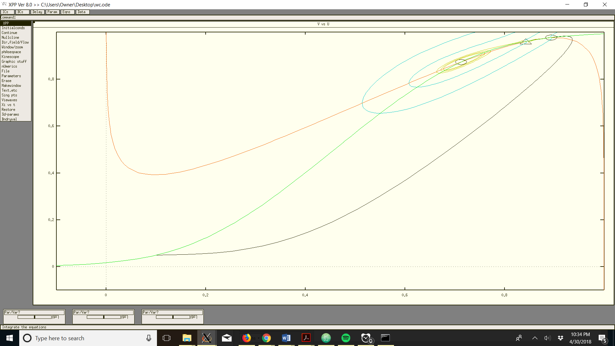

These results gave us some idea as to the dynamical nature of the system.

Since we had studied the phase planes and bifurcation diagrams of the system, we turned our attention to an EEG diagram of a tonic-clonic seizure, which is distinguished from other seizures because it effects the entirety of the brain. The amplitude of the waves is correlated to widespread neuronal firing, and this implies that most of the nerve cells in the region are excitatory. From this, we concluded that a time series solution of the Wilson-Cowan system has to have a predominately excitatory proportion. The EEG diagram below is given as a series of spikes measured with respect to time in milliseconds.

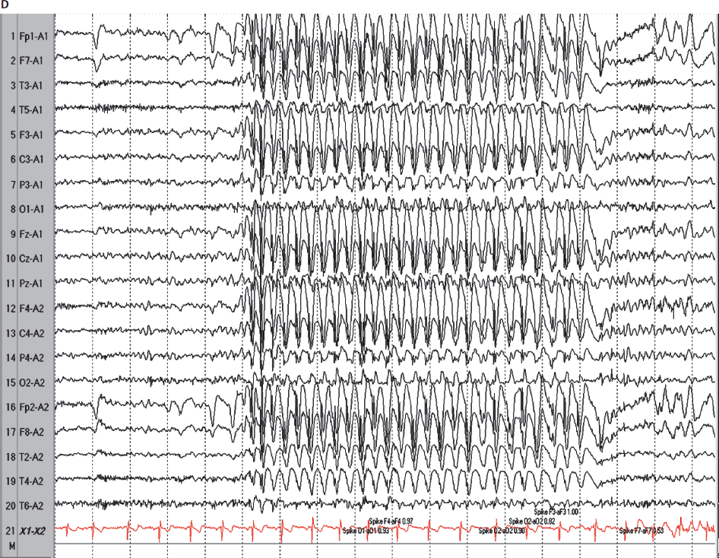

After much experimentation with the parameters in Neuron, we discovered that increasing tau to 80, aie (the inhibitory-to-excitatory connectivity parameter) to 20, ie1 (input to excitatory population coefficient) to 10.5, ii1 (inhibitory input coefficient) to 0.5, we get the following solution:

Image

Since the graph above shows that the excitatory proportion is greater than the inhibitory population for most of the time, we found that this represents epileptiform activity quite well. Though the excitatory population goes to zero for a considerable time, it will always spike back up and continuously influence its neighboring cells.

Discussion

Through the bifurcation diagrams and phase planes in XPP and the time scales in Neuron, we were able to simulate neuronal firing behavior. Although our use of the Wilson-Cowan model was simple, there have been intricate and important extensions of the model made for describing and even treating epileptic seizures in the brain. One such model is the Pinto-Ermentrout model, which is a spatially dependent version of the Wilson-Cowan model that measures the cortical surface of and determines the average firing rate. It has been used successfully to calculate the rate of expansion of hyper-synchronized regions of the brain, which helps to determine how long a seizure may last, or when it may start (Shusterman and Troy 23). Our results helped us understand a large-scale model of the brain, and its aid in the treatment of epilepsy.